
SOUMITH SRIPATHI
2403A51340
BATCH 14
15 SEPTEMBER 2025
LAB 7.1

- Error Debugging with AI: Systematic approaches to finding and fixing bugs

Task Description -1 :
(Syntax Errors – Missing Parentheses in Print Statement)

Task: Provide a Python snippet with a missing parenthesis in a print statement
(e.g., print "Hello").
THIS IS THE INCORRECT PROGRAM :
# Bug: Missing parentheses in print statement
def greet():
print "Hello, AI Debugging Lab!"
greet()

CORRECT PROGRAM AND OUTPUT :
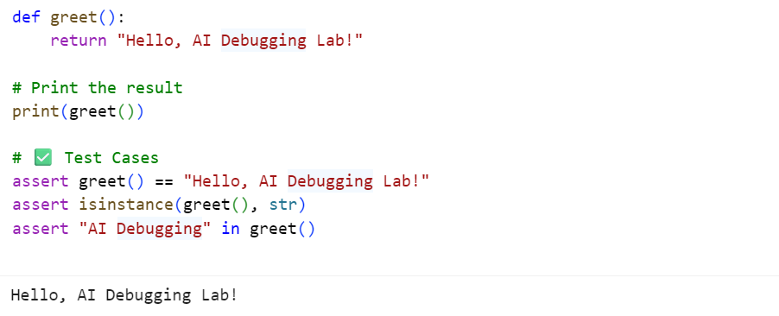

TYPE OF ERROR :
SyntaxError: Missing parentheses in call to 'print'.
It means print("Hello, AI Debugging Lab!")

Task Description -2:
(Logic Error – Incorrect Condition in an If Statement)

Task: Supply a function where an if-condition mistakenly uses = instead of ==.
Let AI identify and fix the issue.
THIS IS THE INCORRECT PROGRAM :
# Bug: Using assignment (=) instead of comparison (==)
def check_number(n):
if n = 10:
return "Ten"
else:
return "Not Ten"
CORRECT PROGRAM AND OUTPUT :
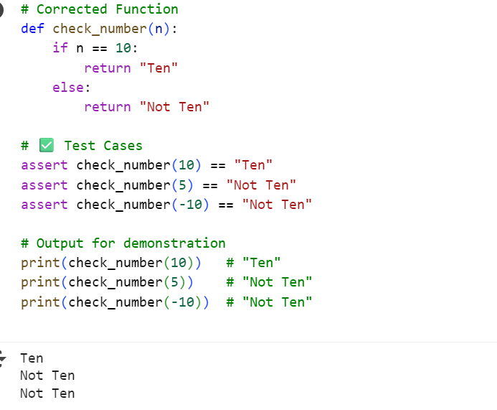

TYPE OF ERROR :
SyntaxError:
Cannot assign to comparison expression here. Maybe you meant '==' instead of '='?

File "script.py", line 3
if n = 10:
^

Task Description -3 :
(Runtime Error – File Not Found)
Task: Provide code that attempts to open a non-existent file and crashes. Use AI to apply safe error handling.

THIS IS THE INCORRECT PROGRAM :
# Bug: Program crashes if file is missing
def read_file(filename):
with open(filename, 'r') as f:
return f.read()
print(read_file("nonexistent.txt"))

CORRECT PROGRAM AND OUTPUT:

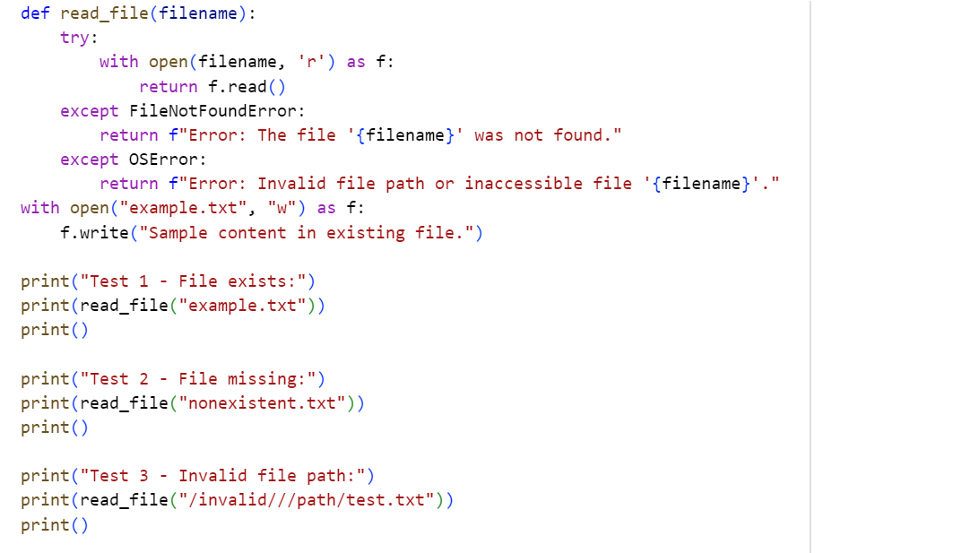
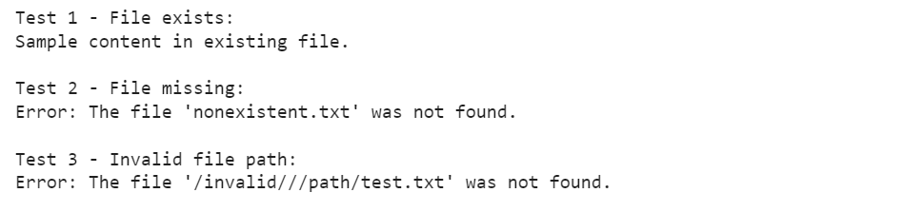

TYPE OF ERROR :
FileNotFoundError:
[Errno 2] No such file or directory: 'nonexistent.txt'
Raised at runtime when trying to open a file that doesn’t exist or isn’t found.

Task Description -4:
(AttributeError – Calling a Non-Existent Method)
Task: Give a class where a non-existent method is called (e.g., obj.undefined_method()). Use AI to debug and fix.

THIS IS THE INCORRECT PROGRAM :
# Bug: Calling an undefined method
class Car:
def start(self):
return "Car started"
my_car = Car()
print(my_car.drive()) # drive() is not defined

CORRECT PROGRAM AND OUTPUT :
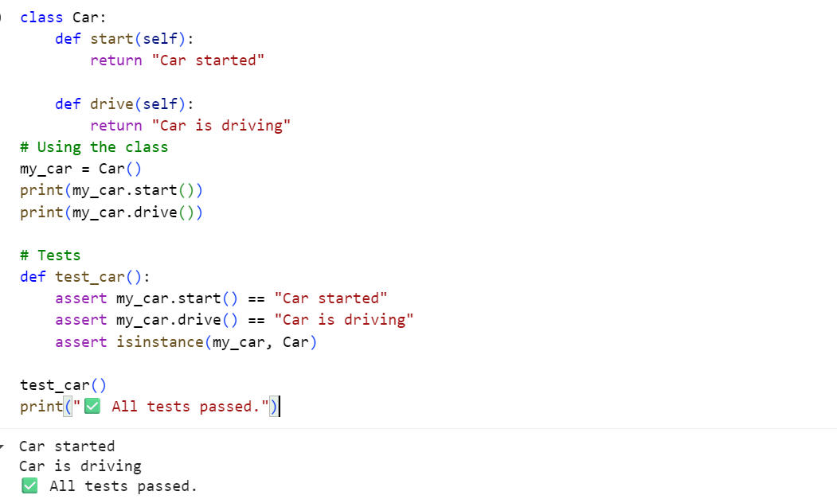

TYPE OF ERROR :
AttributeError: 'Car' object has no attribute 'drive'
Occurs when code tries to access an attribute or method that doesn't exist
Category : Runtime Error

Raised during program execution when the attribute isn't found.

Task Description -5:
(TypeError – Mixing Strings and Integers in Addition)
Task: Provide code that adds an integer and string ("5" + 2) causing a TypeError. Use AI to resolve the bug.

THIS IS THE INCORRECT PROGRAM :
# Bug: TypeError due to mixing string and integer
def add_five(value):
return value + 5

print(add_five("10"))

CORRECT PROGRAM AND OUTPUT :

Test Code for Numeric Addition (Solution 1) :

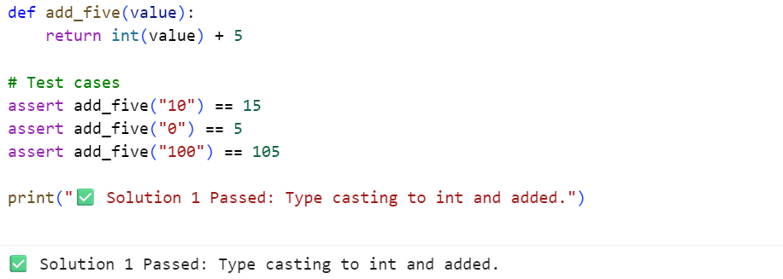

Test Code for String Concatenation (Solution 2):

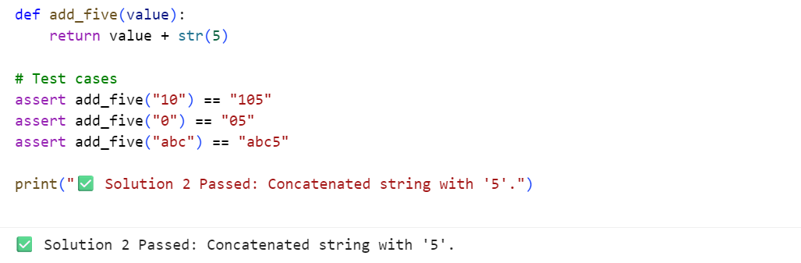

TYPE OF ERROR :
TypeError: can only concatenate str (not "int") to str
A TypeError in Python occurs when you try to perform an operation on incompatible data types.

